MET CS 555 Term Project
10 points (Due December 18, 2022 at 11:59 PM)

1. Assignment Description
Find a dataset for a research problem of interest, here are some good websites for this

Kaggle Data Science Competitions: http://kaggle.com
UCI Machine Learning repository: http://archive.ics.uci.edu/ml/datasets.php
Google Cloud public data: https://console.cloud.google.com/marketplace/browse?filter=solution-type:dataset&_ga=2.265202890.490000482.1586060190-1118401016.1586060190&pli=1

Describe a research scenario and specify a research question based on data analytic methods that we learned in class, for example methods like, one and two sample means, t-test, correlation tests, simple and multiple linear regression, ANOVA and ANCOVA, one and two-Sample Tests for Proportions and logistic regression.

Clean up your data and reduce it to no more than 500 observations if your data set is large. If your task is to build a prediction model, ensure that you split the data into training and testing datasets at this stage.

2. Research Scenario Description (no more than 200 words)
Describe your research scenario in no more than 200 words. This is a general description of the use case. Give relevant background information so that the reader can understand your research question. Assume that the reader does not have any specialized knowledge about your topic. Define all acronyms/abbreviations and try to avoid jargon.

According to the Centers for Disease Control and Prevention (CDC), heart disease is the "leading cause of death for men, women, and people of most racial and ethnic groups in the United States" (CDC, 2022). Approximately 627 thousand persons died from heart disease in 2020, representing 20 percent of all causes of death. The most common types of heart disease are coronary artery disease, which took the lives of 382,820 people in 2020, and heart attacks, which about 805 thousand people suffer yearly. Given the severity of heart disease, the medical industry must analyze the primary causes to find a way to prevent it as much as possible. Therefore, using the statistics of all the people that have suffered from heart disease, one can identify patterns and factors that propel people into being more vulnerable to having any heart disease.

3. Describe the data set (no more than 400 words)
Describe each of the columns of the data set that are used in your analysis. Clean up your data before usage (e.g. asses and remove outliers, perform any necessary transformations, ensure assumptions of your analysis are met). Remove unused columns. Describe each step of your data cleaning process and why you did this step. If possible, provide a link to the main data set source.

The selected dataset is a reduction of the original dataset created by the CDC, which had 279 columns of data on about 400 thousand persons related to their health status in 2020. However, the selected dataset reduced the number of variables to the 18 most significant ones for predicting the risk of having heart disease. From these variables, nine are boolean, five string, and four numerical.

Description of variables:
- Name: HeartDisease
  - Type: Boolean
  - Values: Yes/No
  - Description: Has had a heart disease
- Name: BMI
  - Type: Numerical
  - Values: 0-100
  - Description: Body Mass Index off person
- Name: Smoking
  - Type: Boolean
  - Values: Yes/No
  - Description: Person has had more than 100 cigarettes in their entire life.
- Name: AlcoholDrinking
  - Type: Boolean
  - Values: Yes/No
  - Description: Adult men having more than 14 drinks per week and 7 for adult women.
- Name: Stroke
  - Type: Boolean
  - Values: Yes/No
  - Description: Has had a stroke
- Name: PhysicalHealth
  - Type: Numerical
  - Values: 0-30
  - Description: Number of times with physical activity in last 30 days.
- Name: MentalHealth
  - Type: Numerical
  - Values: 0-30
  - Description: Number of times with mental activity in last 30 days.
- Name: DiffWalking
  - Type: Boolean
  - Values: Yes/No
  - Description: Has difficulty walking or climbing stairs
- Name: Sex
  - Type: String
  - Values: Female/Male
  - Description: Sex of the person
- Name: AgeCategory
  - Type: String
  - Values: 18-24/25-29/30-34/35-39/40-44/45-49/50-54/55-59/60-64/65-69/70-74/75-79/80 or older
  - Description: Has difficulty walking or climbing stairs
- Name: Race
  - Type: String
  - Values: White/Black American Indian/Alaskan Native/Hispanic/Asian/Other
  - Description: Has difficulty walking or climbing stairs
- Name: Diabetic
  - Type: Boolean
  - Values: Yes/No/No, borderline diabetes
  - Description: Person is diabetic
- Name: PhysicalActivity
  - Type: Boolean
  - Values: Yes/No
  - Description: Person engages in any type of physical activity
- Name: GenHealth
  - Type: String
  - Values: Poor/Fair/Good/Very good/Excellent
  - Description: Has had a stroke
- Name: SleepTime
  - Type: Numerical
  - Values: 1-24
  - Description: Number of hours a person sleep
- Name: Asthma
  - Type: Boolean
  - Values: Yes/No
  - Description: Has asthma
- Name: KidneyDisease
  - Type: Boolean
  - Values: Yes/No
  - Description: Has or has had kidney disease
- Name: SkinCancer
  - Type: Boolean
  - Values: Yes/No
  - Description: Has or has had skin cancer

Link to data set: https://www.kaggle.com/datasets/kamilpytlak/personal-key-indicators-of-heart-disease

4. Research Question (no more than 100 words)
Describe the main research question in one or two sentences. This is similar to the last sentence of our class examples.
Analyze the impact of people's habits on heart disease incidence. These habits (variables) include smoking, alcohol consumption, physical health, mental health, and sleep time.

5. Statistical Analysis
Give at least one main visualization that supports your conclusion. Be sure to use correct axis labels and avoid common mistakes when generating visualizations. State all assumptions of the statistical technique(s) that you are using and give evidence as to whether or not these assumptions are met.
Given that the expected value of the outcome it either 0 or 1 and there are multiple independent variables, the most appropriate statistical technique is a multiple logistic regression. Additionally, it was necessary to split the data into the training set (80%) and the test set (20%)

The first step of the analysis was to check for any signs of multicollinearity by calculating the correlation matrix, which as shown in Figure 1, there are no clear signs of multicollinearity between any of independent variables. Therefore, the analysis could be continued with all five variables.

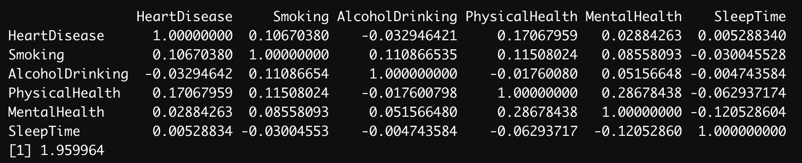
Figure 1. Multicollinearity Matrix

The next step of the analysis was to perform the 5-step experiment to assess if there is an association between any of the independent variables and the incidence of heart disease in a person.

- Hypothesis
  - H0∶ β1 =β2 = ... = βk = 0
  - H1∶ at least one βi ≠ 0
  - α = 0.05
- Select test statistic
  - z = βi / SE_ βi
- State decision rule
  - α/2 = 0.025
  - Decision Rule: Reject H0 if ∣z∣ ≥ 1.96 or Reject H0 if p ≤ α
  - Otherwise, do not reject H0
- Compute test statistic
  - β0 = -3.1178769 → ∣z∣ = 88.611
  - β1 = 0.6913513 → ∣z∣ = 47.068
  - β2 = -0.6748982 → ∣z∣ = 19.091
  - β3 = 0.0503415 → ∣z∣ = 72.755
  - β4 = -0.0085752 → ∣z∣ = 9.642
  - β5 = 0.0335009 → ∣z∣ = 7.326
  - Model → y = -3.1178769 + 0.6913513*(Smoking) – 0.6748982*(AlchoholDrinking) + 0.0503415*(PhysicalHealth) – 0.0085752*(MentalHealth) + 0.0335009*(SleepTime)
  - All five variables have an absolute z value greater than 1.96, being 9.73 the lowest one for SleepTime.
- Conclusion
  - Reject H0 since all ∣z-values∣ ≥ 1.96 or since all p-values ≤ α. There is significant evidence at the α = 0.05 level that all β values ≠ 0. Therefore, there is evidence of an association between all the independent variables and heart disease incidence.

Next steps
Even though the multiple logistic regression inference suggested the association between the independent variables and the dependent one, it si surprising to see a negative coefficient for the AlcoholDrinking and MentalHealth variables. Therefore, it was necessary to compute another model without those variables and evaluate which model has higher accuracy by comparing their log likelihood. From the output of the Likelihood ratio test shown in Figure 2, we can conclude that the full model fits the data better than the nested model.

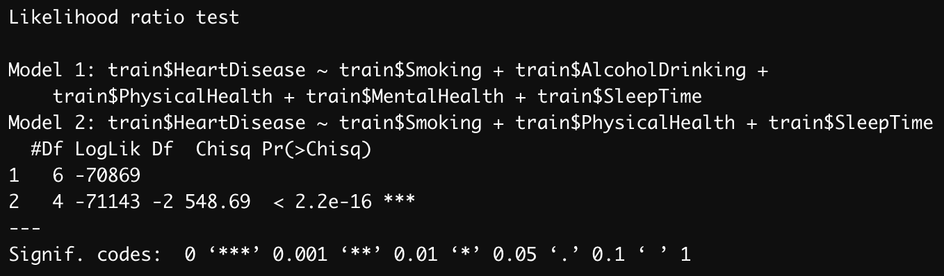
Figure 2. Likelihood ratio test

After concluding that the full model fits the data better than the nested model, the model can be calibrated by analyzing the area under the ROC curve, which is shown in Figure 3. According to the AUC curve, the model correctly predicts the outcome 67.78% of the time. Additionally, we calculated the optimal cut-off value to be 0.0690812, which produced a sensitivity of 68.33% and a specificity of 58.08%.

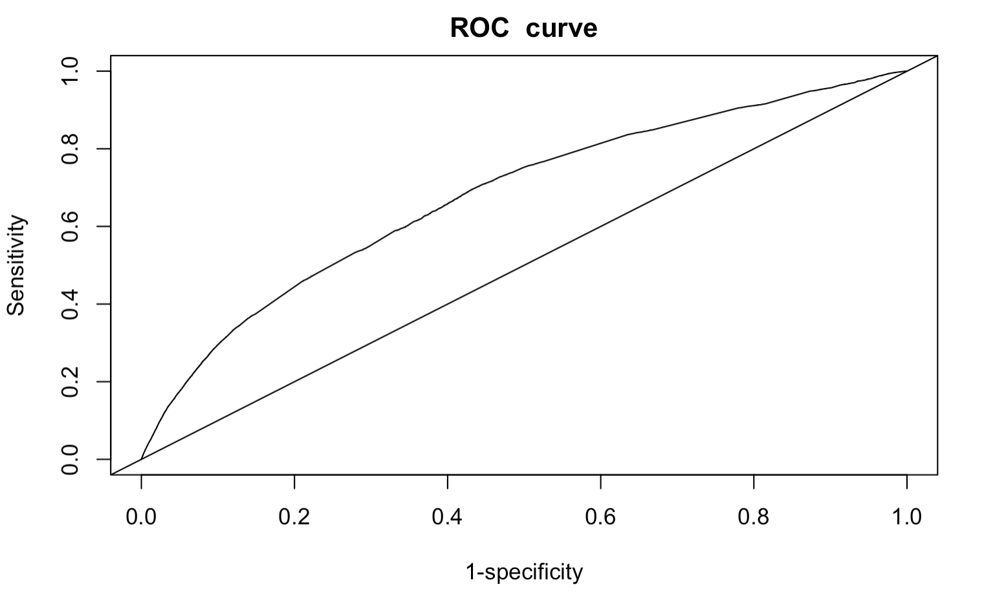
Figure 3. ROC curve

Assumptions:
- Dependent variable is binary.
- Observations are independent of one another.
- Little or no multicollinearity among the independent variables.
- Independent variables are linearly associated with the log odds of the outcome.
- Enough samples.

Evidence of assumptions:
- The dependent variable is HeartDisease, which has the value of either 1 or 0.
- Each observation is data from a single person. Therefore, the data for each person is entirely independent from other persons.
- By analyzing the multicollinearity matrix in Figure 1, it is clear that there are no signs of multicollinearity among any of the independent variables.
- After analyzing the outcome of the model, it is clear that all independent variables are linearly associated with the log odds of the outcome.
- The sample consists of 319,795 people.

6. State Your Conclusion (no more than 100 words)
State the conclusion(s) of your analysis in a way so that a non-statistician can understand.
After performing all the experiments and the analysis, we can conclude that people’s habits have an association with their possible incidence of getting a heart disease. All the analyzed habits are positively correlated except Alcohol Drinking and Mental Health. These results are surprising and suggests that further analysis to observe the relation between of both alcohol consumption and mental health activity with heart disease incidence.

Solution Submission

- Fill up this word file and upload it.
- Upload your data set. This is the data set after cleaning (a small CSV file)
- Submit R code as either a well-commented .R file or as a .Rmd file with associated .html file.

Grading will be done based on
- Originality of selected data set and data analysis approach
- Data Preparation set and cleanup
- General Correctness of data analysis
- Quality of your R code and output results
- Correct final conclusion and useful visualization

